String:

Str (): return a string representation

s. capitalize (): **copy of s** with only the first character capitalized

s. little (): **copy of s**; first character of each word capitalized

s. center (width): center s in a field of given width

s. count(sub): count the number of occurrences of sub in s

s. join(list): concatenate list of strings into one large string using s as separator

s. ljust (width): like center, but s is left-justified

s. rjust (width): like ljust, but s is just right-justified

s. lower (): **copy of s** in all lowercase letters

s. upper (): copy of s; all characters converted to uppercase

s. lstrip (): **copy of s** with leading whitespace removed

s. rstrip (): **copy of s** with trailing whitespace removed

s. replace (oldsub, newsub): replace occurrences of oldsub in s with newsub

s. rfind (sub): like find, but returns the right-most position

s. find (sub): find the first position where sub occurs in s

s. split (): split s into a list of substrings

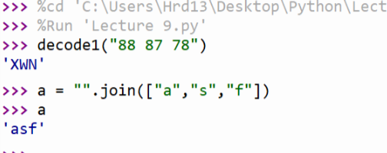

list:

Lists have methods, too

Min (lst)

Max (lst)

List (a string or something) #convert sequence into a list

Lst. Append (“something”)

Lst. Reverse () # reverse in place a list

Lst. Sort () # it is ascending, if we want the descending sequence, use the reverse ()

Lst. Copy () # copy the list, there is no connection between those two lists

s. Join (lst) # s is to be a seperator